**Sales(F8)**

The term **sales** refer to the revenues earned when a company sells its goods, products, merchandise, etc. When a company sells a noncurrent asset that had been used in its business.

Example:

**Goods sold on Rs. 200,000**

Cash a/c ..Dr.200,000

To sales a/c…..20,000

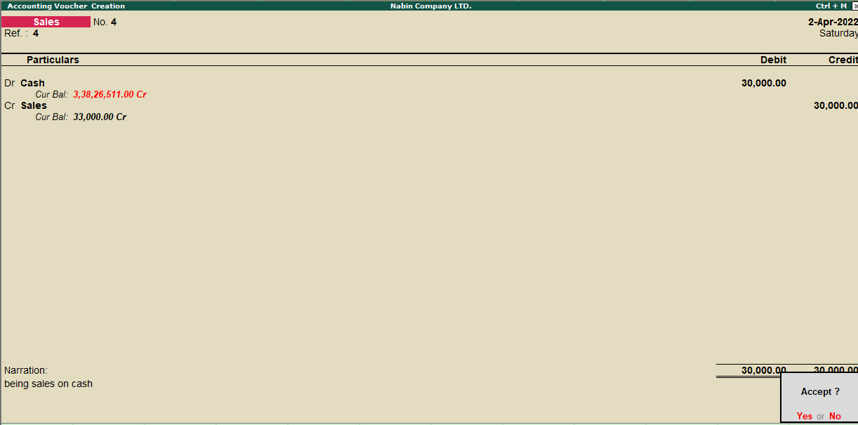

**Goods sold on Rs. 40,000**

Cash a/c ..Dr.40,000

To sales a/c…..40,000

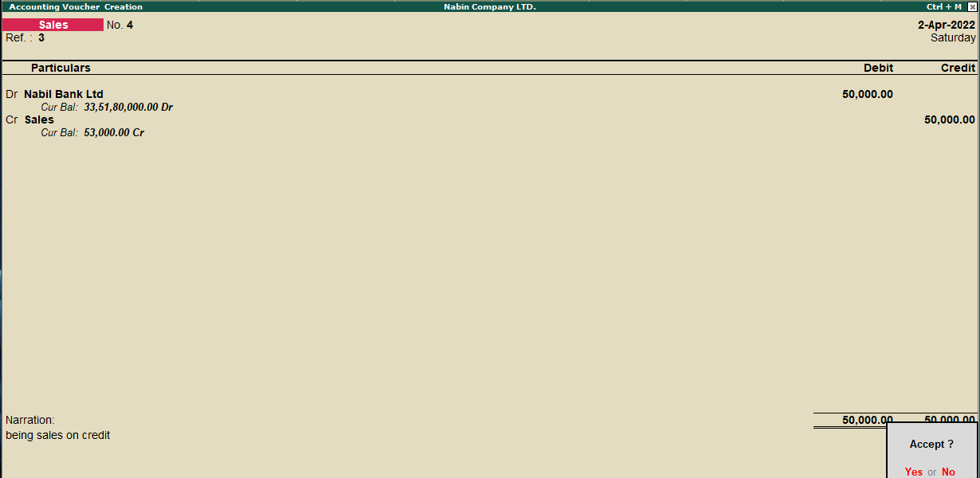

**Purchase(F9):**

A purchase involves the acquisition of goods or services in exchange for a payment of some kind. The payment is usually in cash or credit (to be paid later).

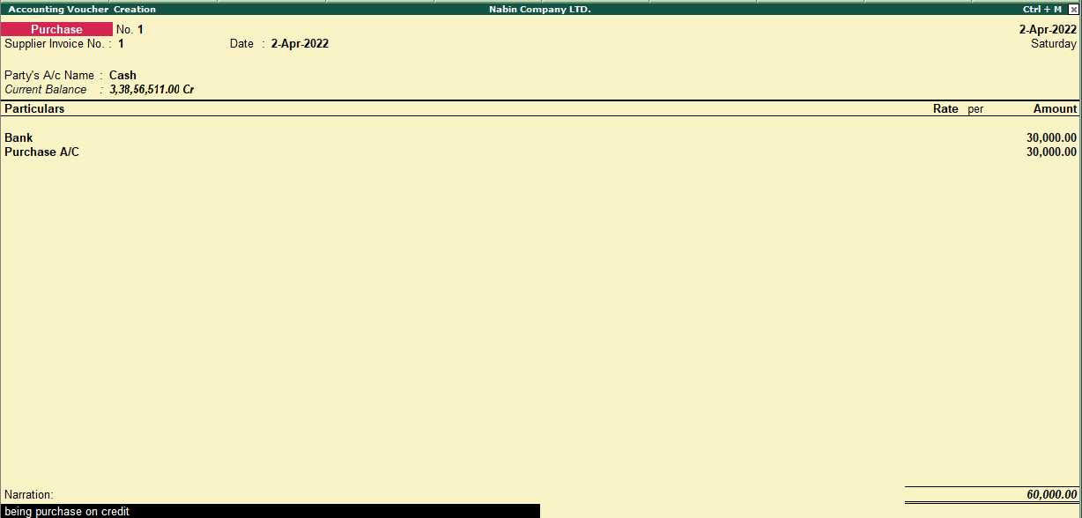

**Goods purchased on Rs. 60,000**

purchase a/c ..Dr.60,000

To cash a/c…..60,000

**Goods purchased paid by cheque Rs. 300,000**

purchase a/c ..Dr.300,000

To cash a/c…..300,000

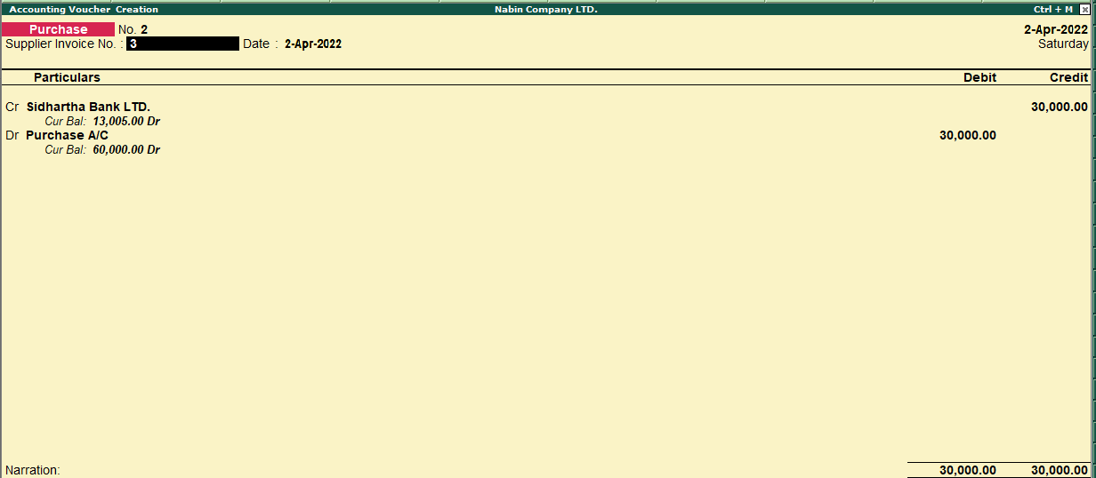

**Daybook**

A daybook is a book of original entries in which an accountant records transactions by date, as they occur. This information is later transferred into a ledger, from which the information is summarized into a set of financial statements. To view all the transactions we entered such as contra, receipts, and payment we have to follow the following steps:

* Go to **Gateway of Tally.**
* Click on **Display** in the Reports Section.
* Click on **Day Book or enter D** on the keyboard.

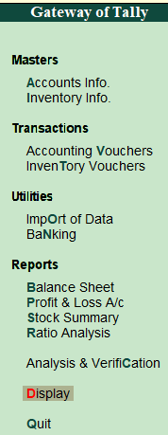 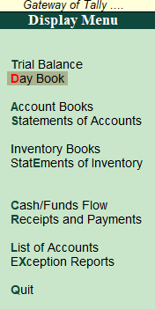

Condensed

In tally, we can view the day book in condensed mode.

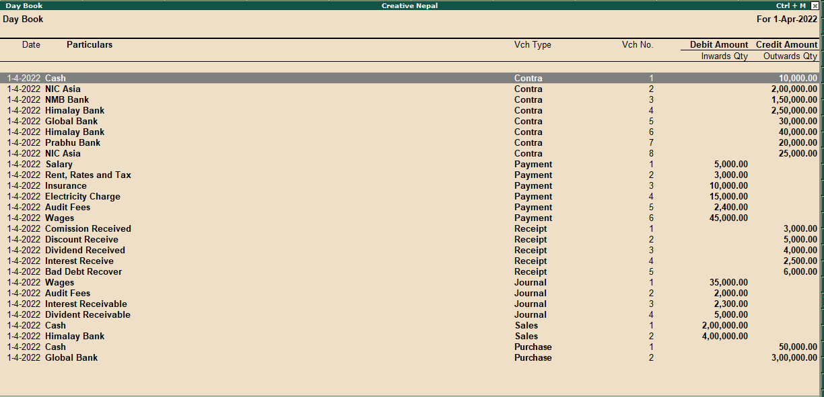

Detailed(F1)  
To view the day book in tally, you can simply click on Detailed or enter F1.